EXP.NO: 6
Write a Servlet to demonstrate session tracking
using HttpSession.
AIM:
To demonstrate session tracking using HttpSession in a Servlet-based web
application. The exercise involves implementing a simple login system where a user can log
in with their username and password, and their session will be tracked throughout their
interaction with the web application.
ALGORITHM:
1.Input:
The user will enter their username and password in a login form.
The servlet will validate the credentials and create an HTTP session for the user if
authentication is successful.
2. Steps for Implementing Session Tracking with HttpSession:
1. Create the Login Form (HTML):
o Create an HTML form with two input fields for username and password.
o Provide a submit button to send the data to the servlet for authentication.
2. Create the Login Servlet:
o Write a Java servlet class to handle login requests.
o The servlet will:
Retrieve the username and password from the form.
Authenticate the user by comparing the credentials to a stored value
(e.g., hardcoded or from a database).
Create a new HTTP session for the user if the credentials are valid.
Set session attributes such as the user&#39;s username to track the session.

3. Validate User Credentials:
o In the servlet, check if the username and password match the expected
values.
o If valid, create a session and store the username in the session.
o If invalid, redirect the user back to the login page with an error message.
4. Create and Track User Session:
o Upon successful login, use the HttpSession object to store the session data.
o Use the session.setAttribute(&quot;username&quot;, username) method to save the
username.
o Optionally, set session timeout using
session.setMaxInactiveInterval(time_in_seconds) to manage session expiration.
5. Redirect to a Protected Page:
o After a successful login, the user will be redirected to a protected page (e.g., a
dashboard or home page).
o The protected page should check if the user is authenticated by checking the
session attribute.
6. Logout and Session Invalidation:
o Provide a logout feature that invalidates the session using session.invalidate()
when the user logs out.
o After logout, redirect the user back to the login page.
7. Session Expiration:
o If the session expires or the user manually logs out, the session will be
invalidated, and the user will be redirected to the login page..

CODE:
Index.html:
<!DOCTYPE html>
<html>
<head>
<title>MiniTimes India</title>
<style>
body{
font-family: Arial;
margin:0;
background:#f2f2f2;
}
header{
background:#c40000;
color:white;
padding:20px;
text-align:center;
font-size:30px;
font-weight:bold;
}
nav{
background:#222;
padding:10px;
text-align:center;
}

nav a{
color:white;
margin:15px;
text-decoration:none;
font-weight:bold;
}
.container{
width:40%;
margin:auto;
margin-top:40px;
background:white;
padding:30px;
box-shadow:0px 0px 10px gray;
}
h2{
text-align:center;
}
input{
width:100%;
padding:10px;
margin:8px 0;
}
button{
padding:10px;
border:none;
color:white;
cursor:pointer;
width:100%;
}
.getbtn{
background:#007bff;
}

.postbtn{
background:#28a745;
}

footer{
margin-top:40px;
background:#222;
color:white;
text-align:center;
padding:10px;
}

</style>
</head>
<body>
<header>
MiniTimes India
</header>
<nav>
<a href="#">Home</a>
<a href="#">Politics</a>
<a href="#">Sports</a>
<a href="#">Technology</a>
<a href="#">Contact</a>
</nav>

<div class="container">
<h2>Subscribe for Breaking News</h2>
<form action="FormServlet" method="get">
<label>Name</label>
<input type="text" name="name">
<label>Email</label>
<input type="text" name="email">
<button class="getbtn">Subscribe using GET</button>
</form>
<br>
<form action="FormServlet" method="post">
<label>Name</label>
<input type="text" name="name">
<label>Email</label>
<input type="text" name="email">
<button class="postbtn">Subscribe using POST</button>
</form>
</div>
<footer>
© 2025 MiniTimes India | Daily Digital News Portal
</footer>
</body>
</html>Style.css:
*{
margin: 0;
padding:0;
}

nav{
background-color: black;
color: blueviolet;
padding:20px;
}
.one li,h1,ul{
display: inline;
}
.one ul{
margin-left: 55%;
}
.one li{
font-size:x-large;
cursor: pointer;

}
.one li:hover{
color:rgb(7, 166, 246);
}

.box1 iframe{

border-radius: 30px;
}
h2{
color: rgb(219, 146, 236);
}
body{

background-image: url("img3.jpg");
background-size: cover;
background-repeat: no-repeat;
background-position: center;
background:linear-gradient(rgba(0,0,0,0.8), rgba(0,0,0,0.8)),url("img3.jpg");
text-align: center;

}
.box2 iframe{
border-radius: 30px;
}

.box3 li{
font-size: x-large;
color: azure;
}
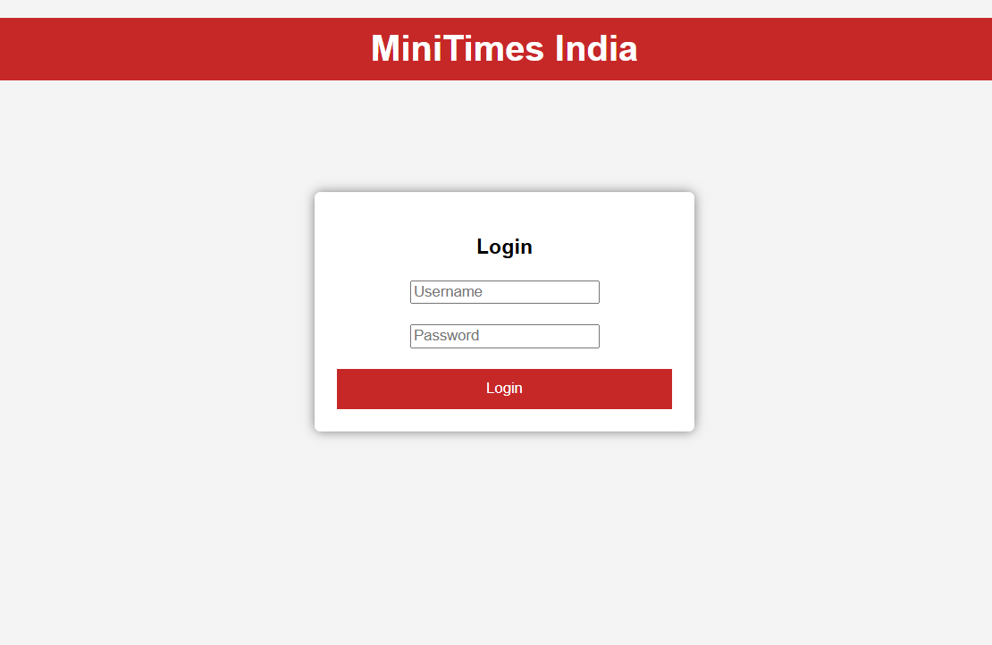
OUTPUT:

Result:
A simple login system is created where the user&#39;s session is tracked by a servlet to
demonstrate session tracking using HttpSession.

